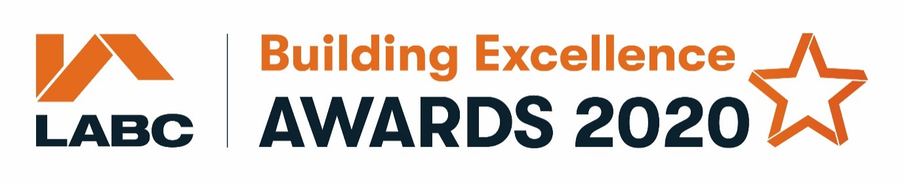

Below is the list of information and questions that will be asked when you enter into the
Best Partnership with a local authority building control team category

Please note that the fields marked with a * are mandatory

Submitter Information
You will need to fill in the details of the person completing the form including:

Title*
First name*
Last Name*
Do you work in a local authority building control team?*
Job Title*
Company*
Email*
Telephone*
Company Twitter username

This is going to be the main point of contact if we have any queries regarding the entry

Nomination Section
This is where you tell us about the relationship, team working and projects undertaken in association with your local authority building control team.

Award year*

Region*

Tell us more (please refer to the general & category specific judging criteria when completing these sections)

There is one mandatory subheading below. In the comment box you will need to add a minimum of 200 words. The text below the subheading refers to the category specific criteria, but please also refer to the general criteria.

- Partnership and relationship with LABC – why should the partnership win? (min 200 words)*
How long has the partnership been going? Have any innovative solutions been developed as a result of working together? How did you overcome challenges together? What are the strengths of the partnership and value gained? Has there been a consistent high standard of work? What were the benefits for the client? What is special or unique about the partnership?

Partner Company
You will need to add the details of the company that is being entered in to the partnership category including:

Partner contact title*
First name*
Last Name*
Job Title*
Partner Company*
Email*
Telephone*
Company Twitter username
Address Line 1*
Address Line 2
Town/City*
Postcode*

Partner Authority
Please add information about the local authority you have the best or most longstanding relationship with.

Local Authority Name*
Title*
First Name*
Last Name*
Email*
Telephone*
Address Line 1*
Address Line 2
Town/City*
Postcode*

Project Photos*
Please upload a minimum of three, maximum of six hi-res photos of recently completed projects (ideally 300dpi or 2000 pixels (is to ensure that the events team have a good quality selection of photographs to choose from for any awards material e.g. brochures and presentations).

Take them on a sunny day if possible so they show the project at its best! Project plans are also helpful so please include these were applicable.

