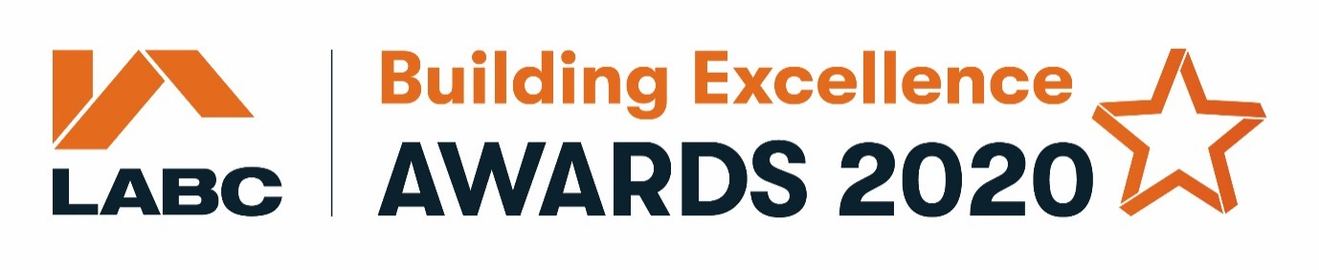

Below is the list of information and questions that will be asked when you enter into the
Site Based categories

Please note that the fields marked with a * are mandatory

Submitter Information
You will need to fill in the details of the person completing the form including:

Title*
First name*
Last Name*
Do you work for a local authority building control team?*
Job Title*
Company*
Email*
Telephone*
Company Twitter username

This is going to be the main point of contact if we have any queries regarding the entry

Award year*

Region*

Project Information

Site based categories (one project can be entered into a maximum of 4 categories)*
Tick the categories you are entering

- Best extension or alteration to an existing dwelling
- Best change of use of an existing building
- Best individual new home
- Best new housing development
- Best social or affordable new housing development
- Best public service or educational building
- Best commercial project

Description of project*

Project Name and Address*
Max 50 characters

Number of plots*

Tell us more (please refer to the general & category specific judging criteria when completing these sections)

The below subheadings marked with * are mandatory. In each comment box you will need to add a minimum of either 50 or 100 words. Each subheading refers to the general criteria, so please also refer to the category specific criteria.

- Building regulation challenges and how you overcame them?* (min 100 words)
Give us examples of challenges you faced in meeting regulations, (i.e. because of site conditions). How did the site teams and building control team work well collaboratively? Were communications between teams effective, please give examples (i.e. using the LABC inspection app, arranging pre commencement meetings). Did you receive the right information before and during the project?

- Performance & sustainability* (min 50 words)
Tell us about the use of renewables, BREEAM, SBEM, low air leakage, good expected running and life-cycle costs.

- Site & project management* (min 50 words)
How did you ensure that sites were safe and healthy? What active waste management strategies did you use and how did you implement them? Did sub-contractors maintain your high standards?

- Innovation & problem-solving* (min 50 words)
Were innovative products used or new ideas implemented? Were new technologies used and were creative designs/solutions/approaches applied to tricky situations?

- Inclusivity – Where applicable, please complete this section if your project exceeds Part M of the building regulations. (min 50 words)
Is there evidence of an inclusive approach which exceeds Part M of the building regulations? Does the design incorporate the needs of a wide range of users? What design guidance was used? Was there any involvement of access professionals or access groups?

The final question on the form is an opportunity for you to tell us more about what is special or unique about the project you are nominating. This box requires a minimum of 100 words.

- Why your project should win?* (min 100 words)
What’s special or unique about the project? What makes the project stand out? Were projects delivered on time and on budget? Was the client happy with the project?

Completion Date*
This is the date that the project was completed on site. U.S date format MM/DD/YYYY

Local Authority Building Control Surveyor
This should be the surveyor you worked with from your Local Authority Building Control team:

Local Authority*

Building control surveyor title*
First name*
Last Name*
Job Title*
Company*
Email*
Telephone*
Address Line 1*
Address Line 2
Town/City*
Postcode*

Project Team Members – please add the details of the project team members involved in this project

Contractor Company
These are the contact details for the contractor involved in the project.

Contractor Title*
First Name*
Last Name*
Email*
Telephone*
Company Twitter username
Address Line 1*
Address Line 2
Town/City*
Postcode*

Architect/designer Company
Please complete your project's architect or designer contact details.

Architect/designer title*
First Name*
Last Name*
Job title*
Company*
Email*
Telephone*
Company Twitter username
Address Line 1*
Address Line 2
Town/City*
Postcode*

Client
This is where you'll complete the client's contact details.

Client Title*
First Name*
Last Name*
Job title*
Company*
Email*
Telephone*
Company Twitter username
Address Line 1*
Address Line 2
Town/City*
Postcode*

Do you have other project team members you’d like to include? A maximum of 4 other team members can be added

Project Photos*
Please upload a minimum of 3, maximum of 6 hi-res photos (ideally 300dpi or 2000 pixels to ensure that the events team have a good quality selection of photographs to choose from for any awards material e.g. brochures and presentations).

Take them on a sunny day if possible so they show the project at its best! Project plans are also helpful so please include these were applicable.

